Storage Accounts

1. It is one of the highly resource in Azure as well as more consuming service. There are 2 types of storage one is persistent storage (hardware, USB,) means it is permanent once saved we cannot delete and second is non persistent storage is ( RAM. Data will be randomly injecting and go way with in fraction of seconds) which is out of control
2. In the system there is a local storage inside the CPU motherboard connected storage
3. Storage will store the data. If we have issues with motherboard, data will be secured by the methods DAS, (Directed attached storage), NAS(Network attached storage) . currently running is SAN (Storage area network). Now we have cloud storage (we can access the service from any where like google drive and drop box)
4. Highly available and durability.
5. Azure storage is pure cloud storage
6. Local storage: Hard drives will be locally connected any problem to motherboard or any further issues it will affect the hard drive
7. SAN and FibreChannel SAN: San is less cost can be used for dev and sandbox environment. Suitable for short distance and FC is suitable for long distance.
8. Physical server like hyper V: CPU, RAM and networking only used and whereas in storage will be used from SAN
9. If any underline server is down in which it is mounted in 10 machines in this case VM will be shifted in another VM. VM Ware software help us to move failed host to running host
10. With out SAN it is not possible. If SAN fails total VMS will be down
11. If you want disk storage we will give storage accounts
12. Storage account name will be always small lettersand the name should be unique which is exposed to internet across all the platforms
13. Based on performance selection the options account kind, Replication, and Blob access tier will change. Based on the region also the options will be changed.
14. 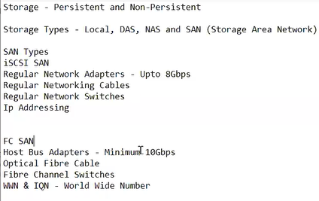
15. 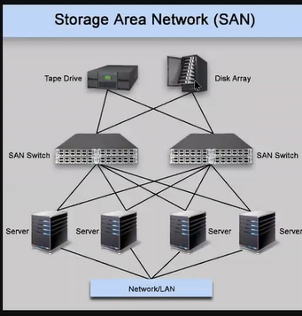
16. 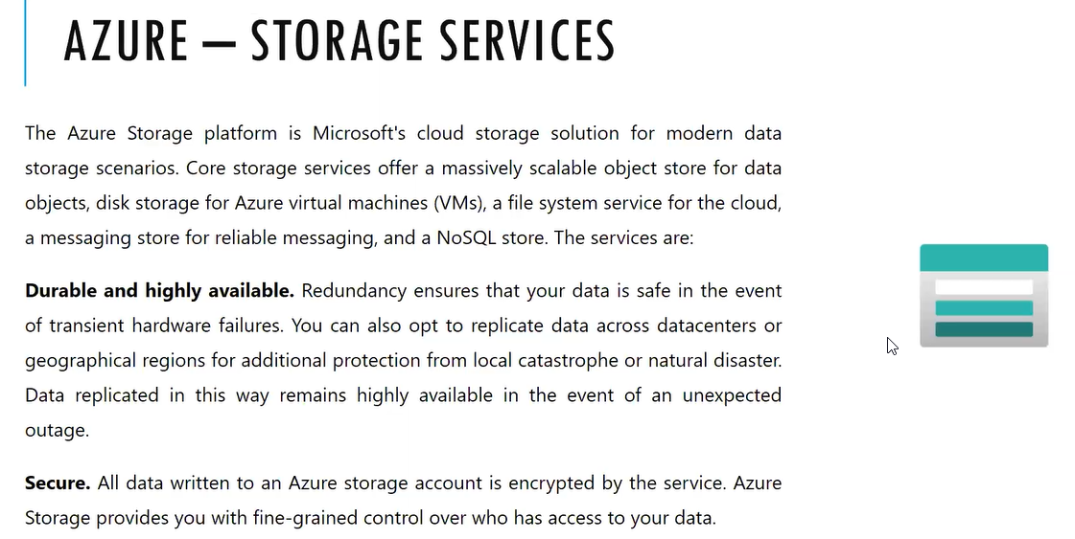
17. 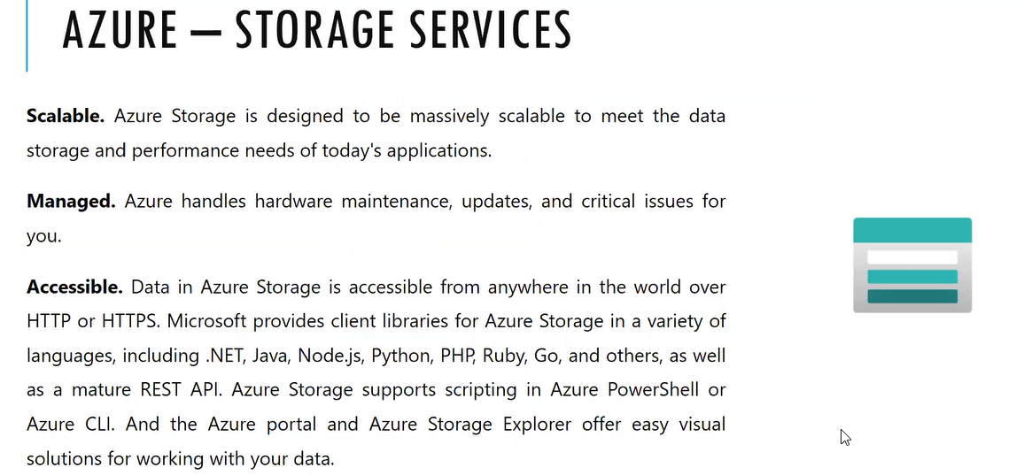
18. Performance : standard and premium
19. 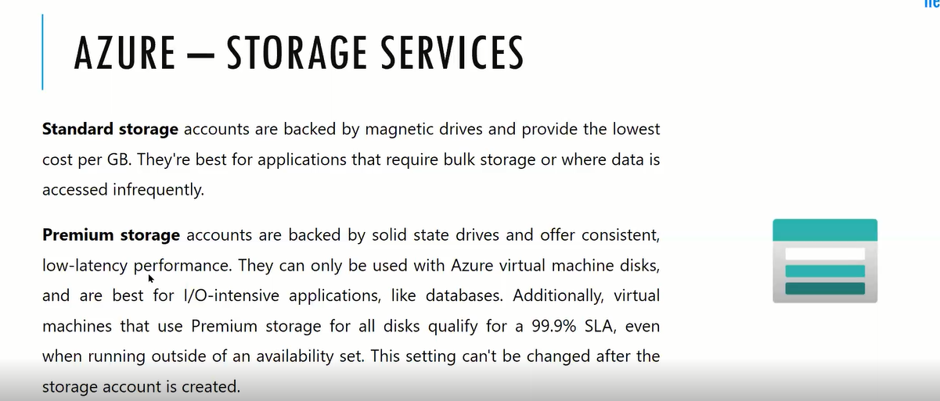
20. 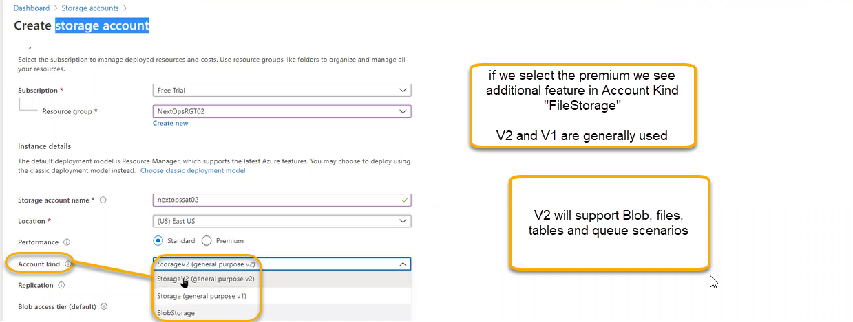
21. 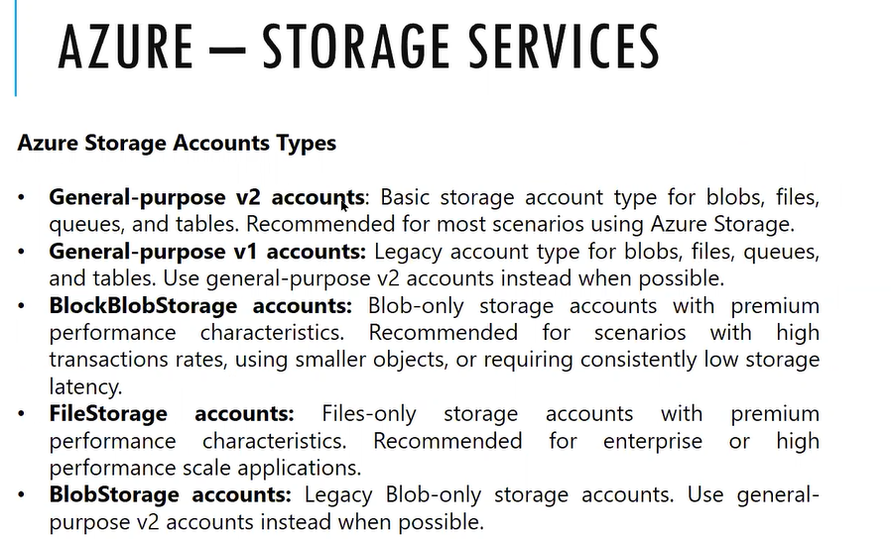
22. Performance :wil define storage account performance
23. Account Kind: will define the features
24. Replication: will define the features based on account kind
25. Blob access tier: Cool and hot hot is for production
26. Data will be stored in many ways. Present recording data or live data, website data, or any kind of data injected right now that is hot. Infrequent data access is cool. Retrieval cost is low for hot where it is high for cost. General cost is high for hot whereas low for cool
27. Example: when anyone go hospital first time visit is live record,
28. Blockbobstorage: used for high transmission data
29. Replication: If SAN storage is failed/ completely dead then it that situation how we need to protect

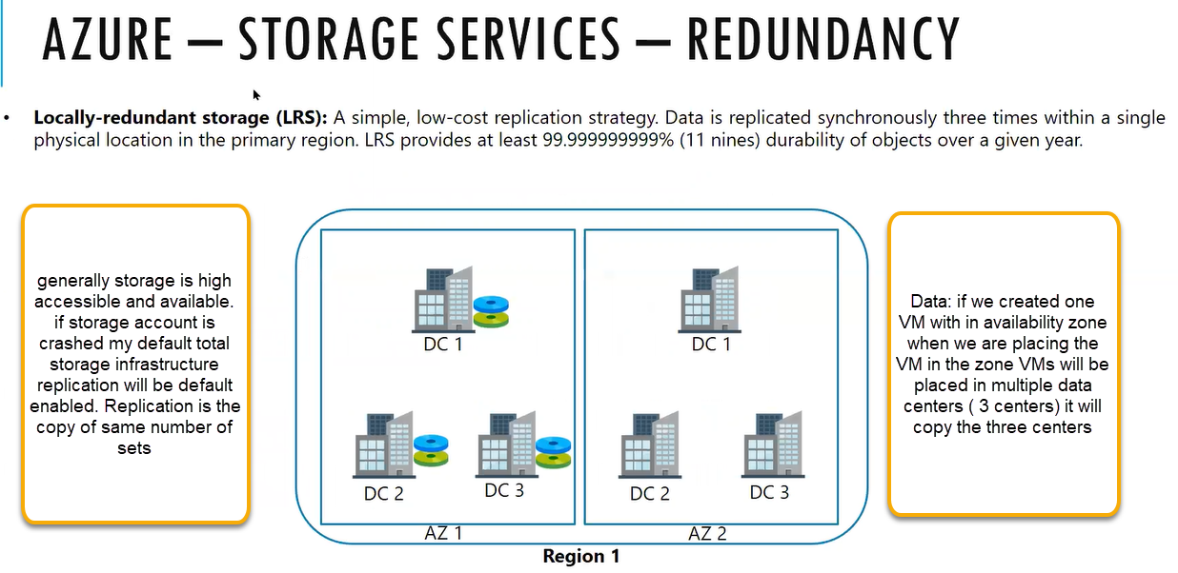

We have created the VM and attached one O.S Disk and data disk and whole set is stored in data center and another 2 copies will be stored another data center

If DC2 is crashed our VM data is safe since it is saved in DC1 and DC3 Our VMs will be safe

When we power on ,the VM it will figure out the reason how it fails\

3 copies will created that is minimum protection

If AZ1 is completely down due to natural calamity then VMS completed down to overcome this select the ZRS

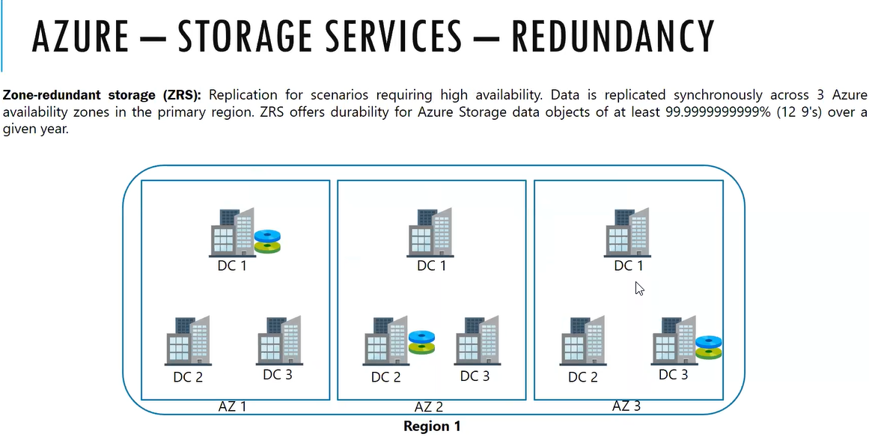

Synchronously: if we do any change to VM then automatically the change will reflect to second with in fraction of seconds

Non Synchronously: if we do any change to VM then it will take 10-15 seconds to the change to reflect to second VM

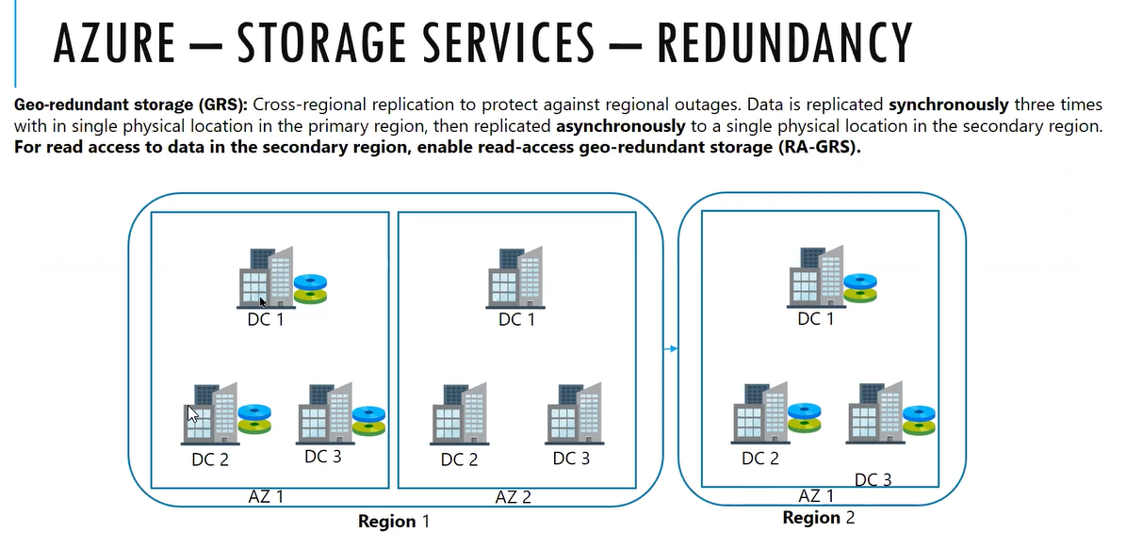

Region 2 is in access until Region is 1 completely failed. Read and write access will be given to Region 1 and where as for the Region 2 we will give only read access

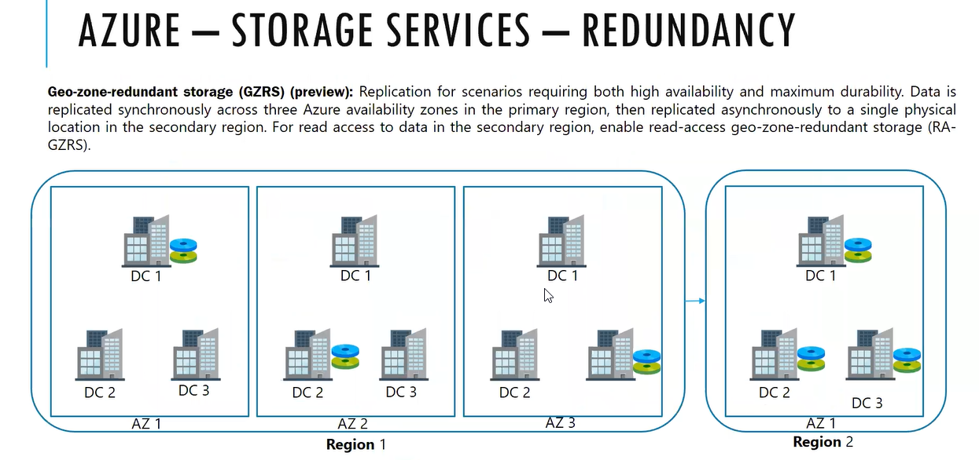

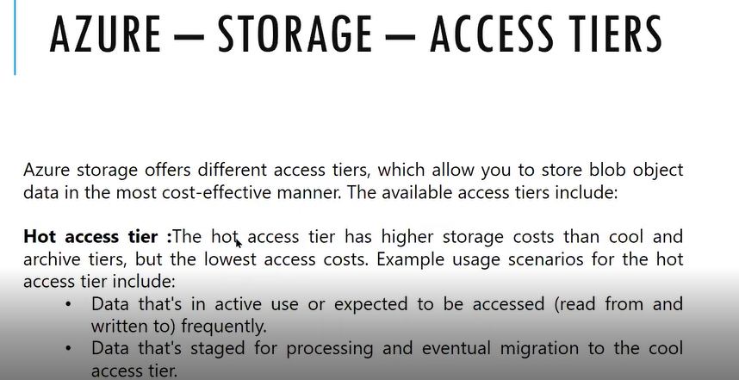

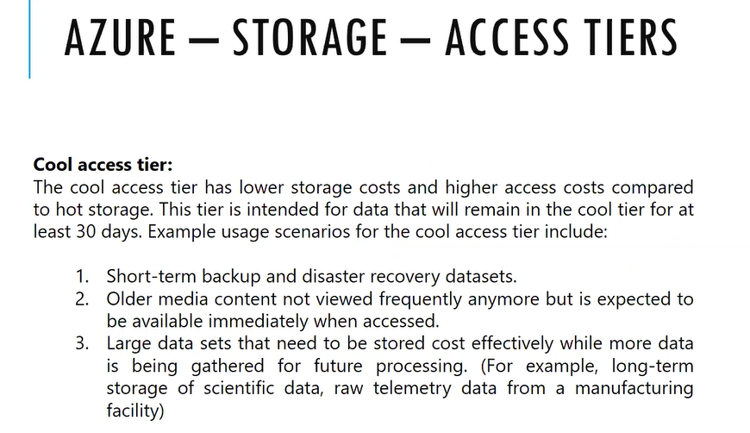

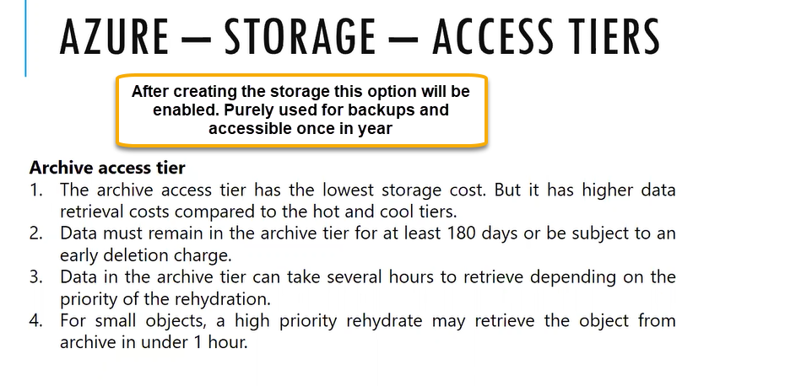

Retrieval cost is very high

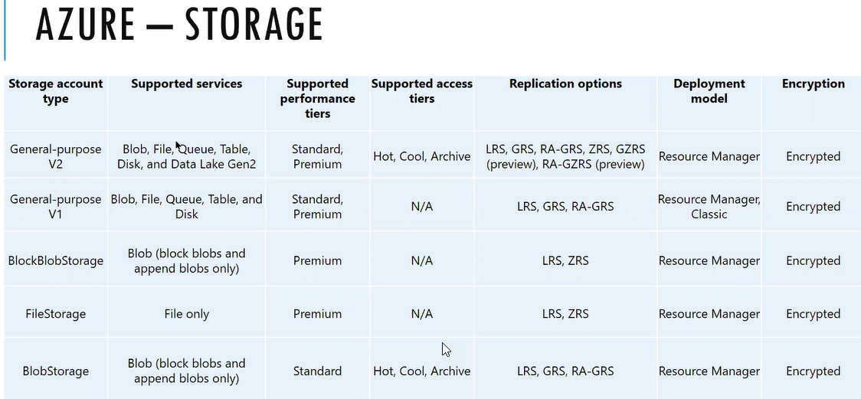

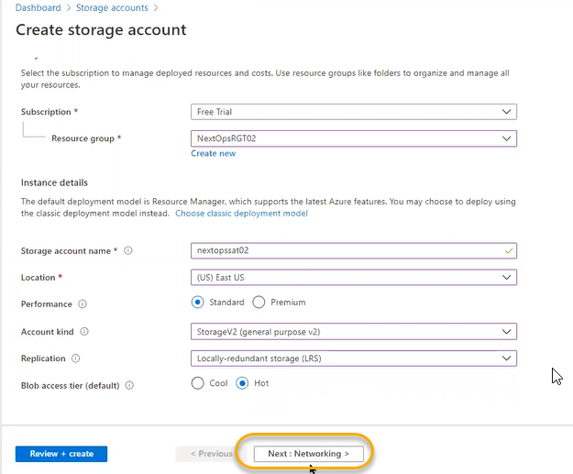

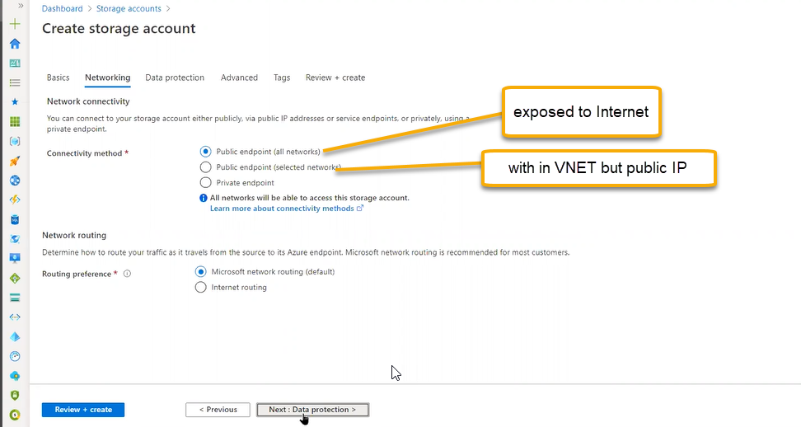

Data protection: after deleting the data and for restoring to previous state when accidently deleted

Point In time restore: previous state we need to retrieve the storage account data then we need enable the versioning, Change feed, RestoreBlob ranges

Turn on soft delete If we delete accidently and if we mention how many days to preserve immediately just like recycle bin

For now enable point in time, versioning, Change feed, RestoreBlob ranges and click on the NEXT

In advanced tab provide you how the transfer will happen and access

If you enable Blob public access aa bob ku vachina url nunchi internet unna prathi device nunchi we can open storage account

If you disable then it is private url is public but access will be private

For every storage account multiple public urls will be generated through that we wil access data

And for remaining options select the default options

Click on Next and Review and create

Create

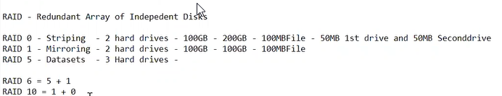

Based on the index datasets will be created any one of the hard drives will fail using the metadata it will retrieve

Storage container basic scenario is Raid 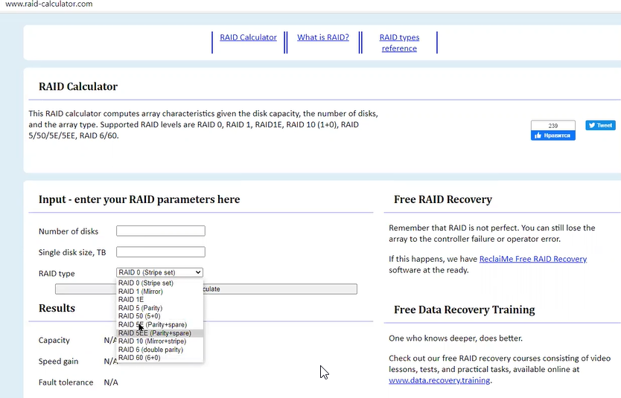

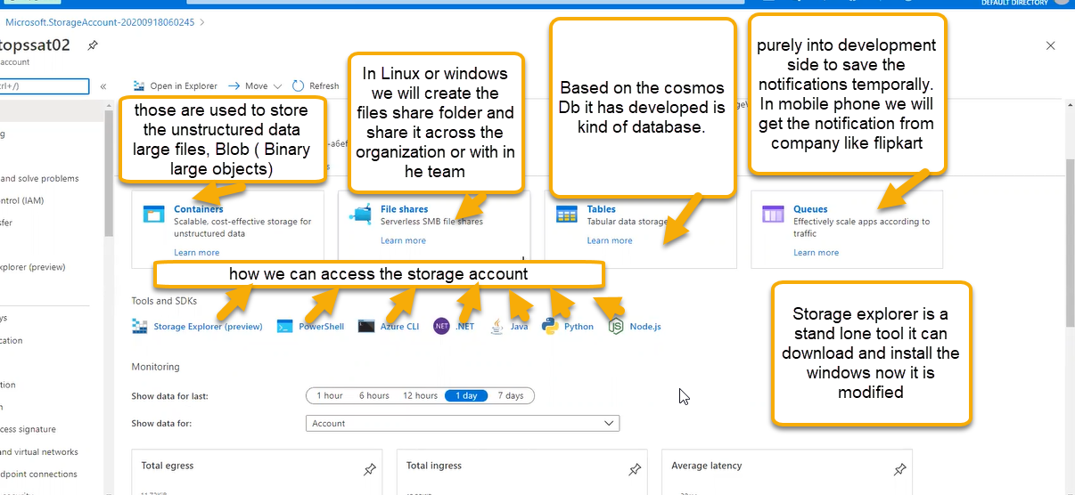

Datatransfer: There are 2 types of data transfer. It is used for migration. Suppose our infrastructure is in on-premises and we need to migrate to Azure

Inside the on-premises, machines, virtual machines or related data if we need transfer or if our bandwidth does not support or we have huge amount of data and we need to place in Azure.

On premises devices: compress the data before the data send so that transfer will be fast

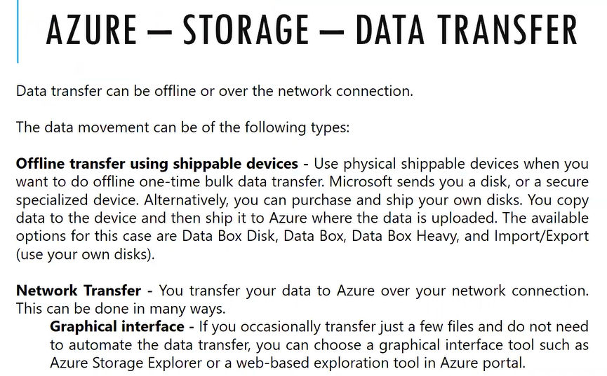

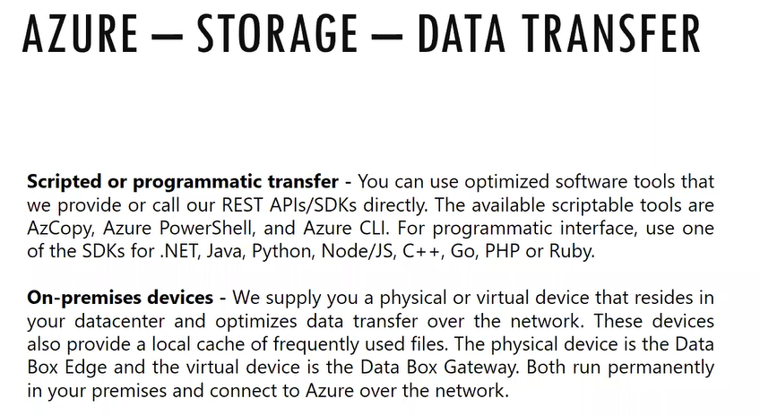

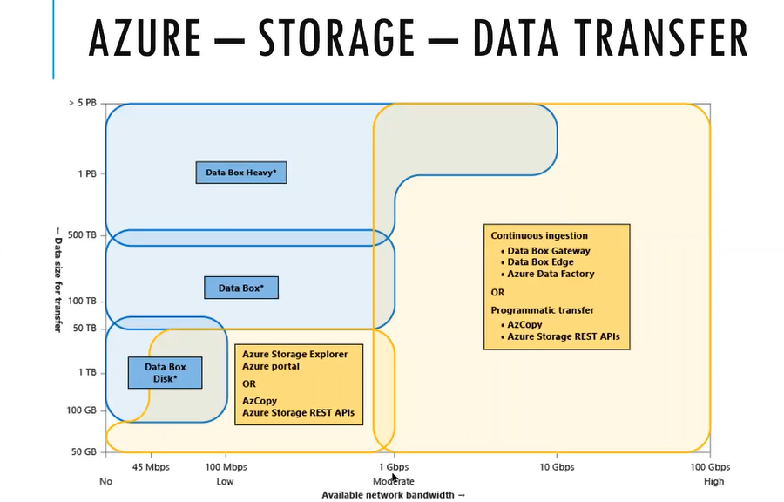

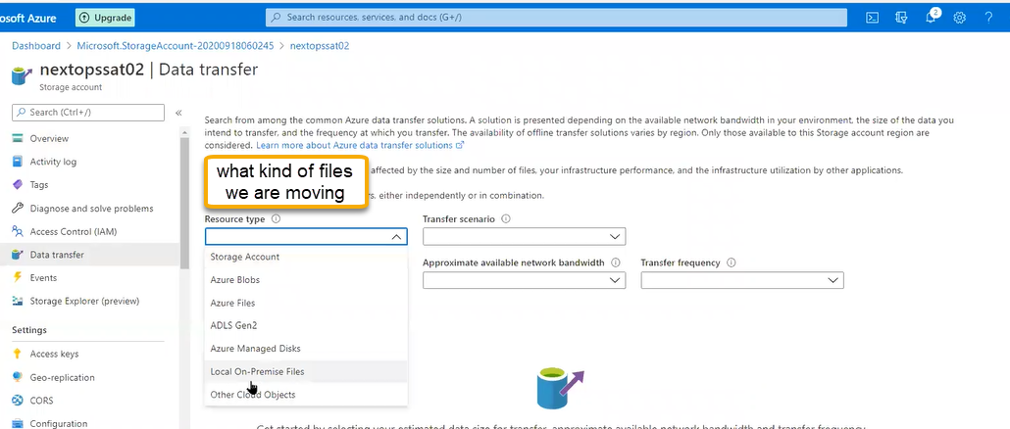

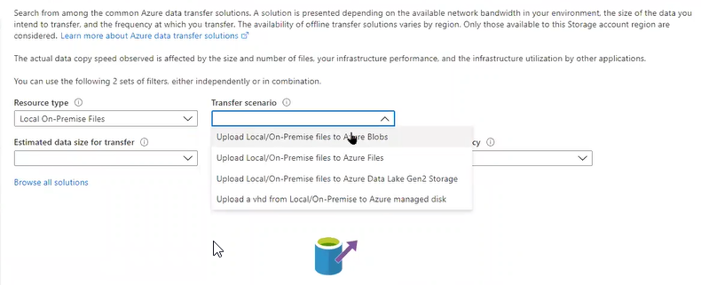

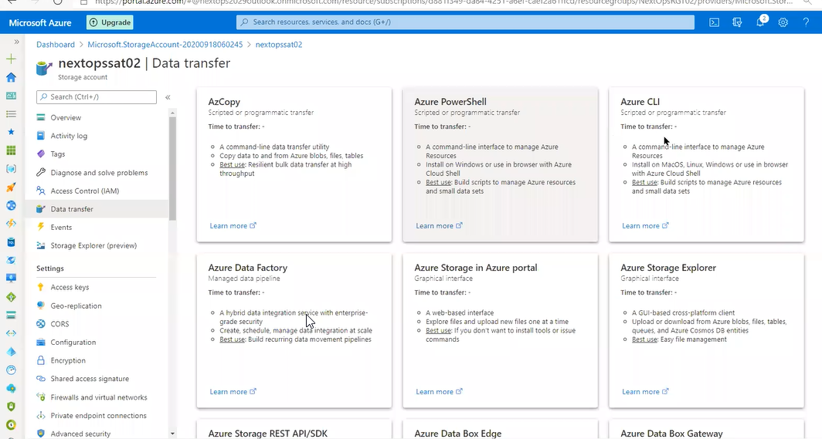

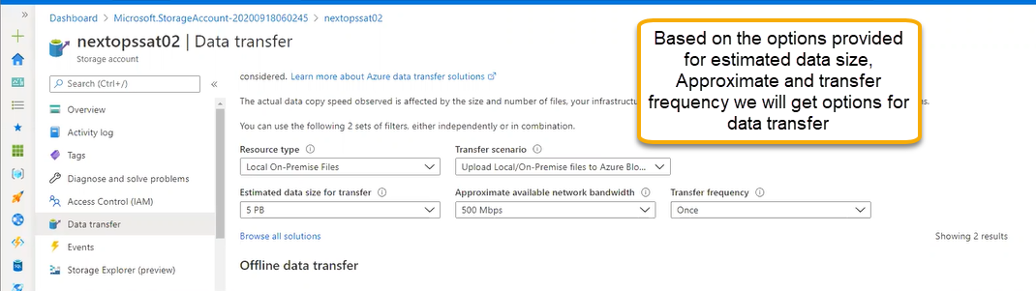

Events

For static web site we can use backend as storage account. Any content has uploaded, or any file drop we can configure logic app/azure function

For any kind of automation, it is operating trigger the function, Images are uploading in the website we can mention that upload the image as hot to cool tier and if we mention the steps we can do the automation for logic app there is no need of code we will define the steps

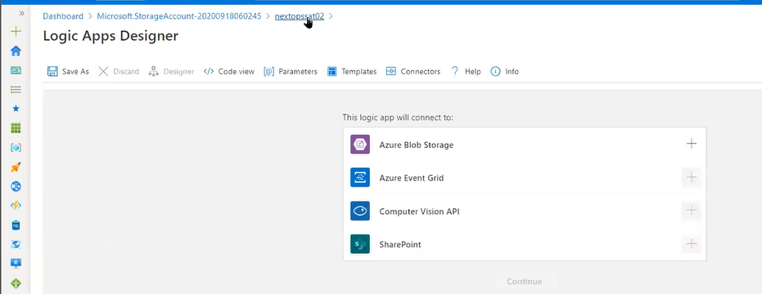

Azure function is serverless communication

Function any programming language if you want to perform the activity there will be different components, inputs like variables. So instead of computing we can set up in azure function. No need to install any c or other language we can do it directly from platform

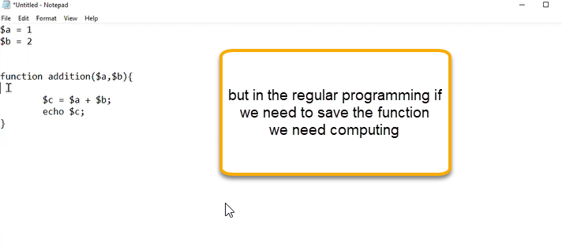

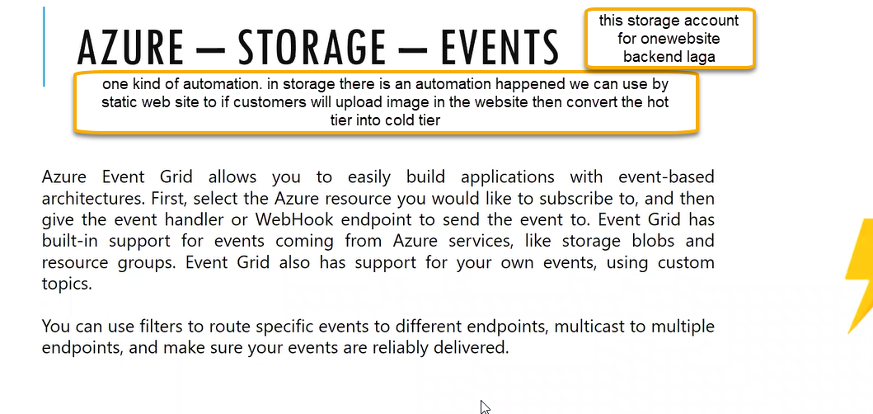

Storage explorer: one kind of tool will be there in windows that is Microsoft storage explorer came from Azure suppler.

We can install as standalone tool

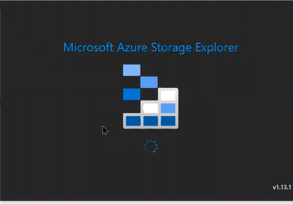

The options available in storage explorer we can see the same in Microsoft storage explorer if you subscribe with same login

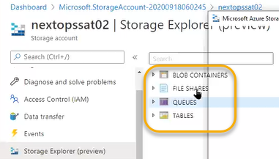

After logging we can see the options in both places. The storage subscriptions we can see in the Microsoft storage explorer if you want to upload any files from system or to download the files from storage account we can do it from Microsoft storage explorer

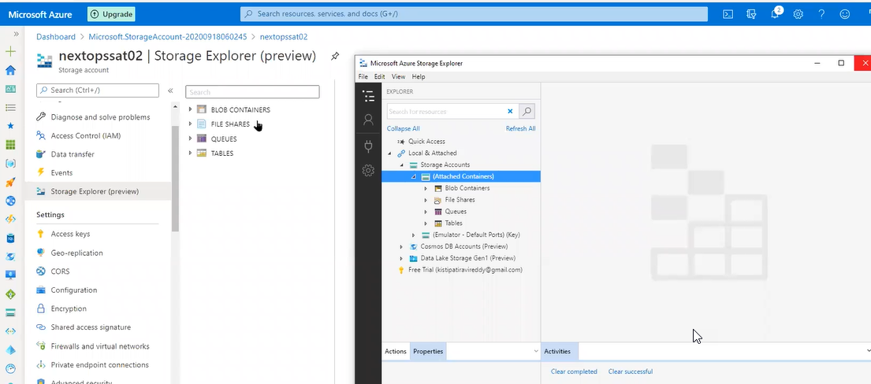

Access keys

For storage account there will be two keys by default azure will generate the keys. I some scenarios for connecting the storage account we need access keys

For storage account if we are connecting with web app, we need connection strings. We can access many programming languages. If we use the website for any back end we need to use access keys

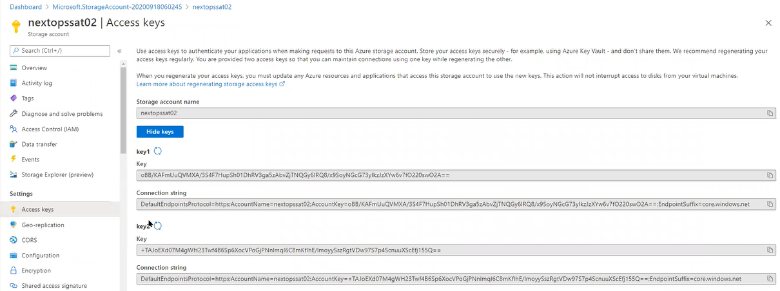

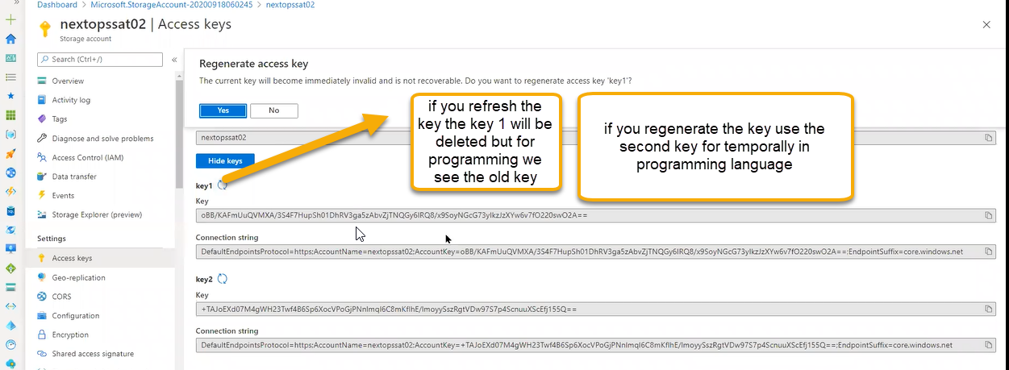

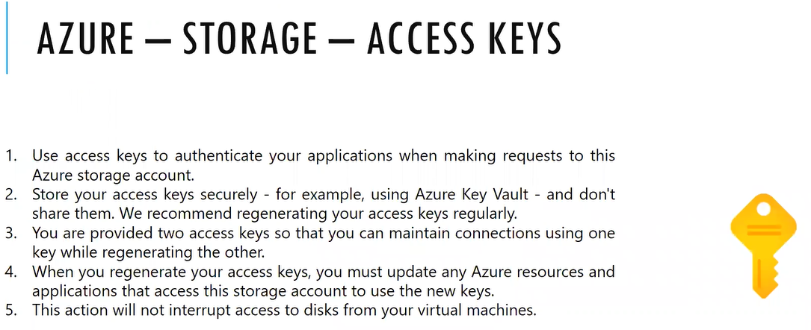

Geo-Replication:

For our subscription east us is the primary and west us is the secondary

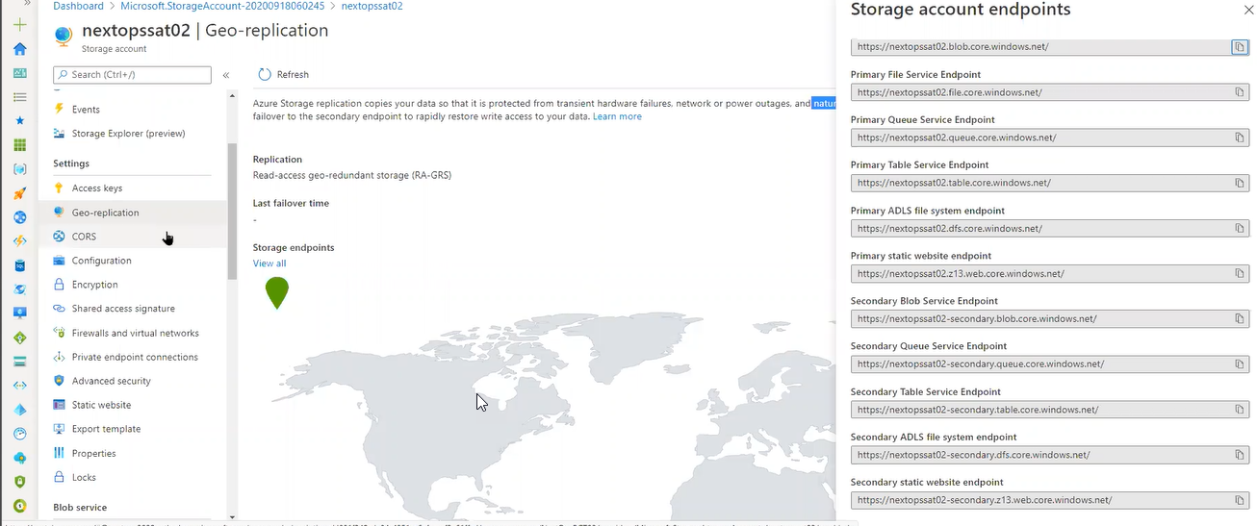

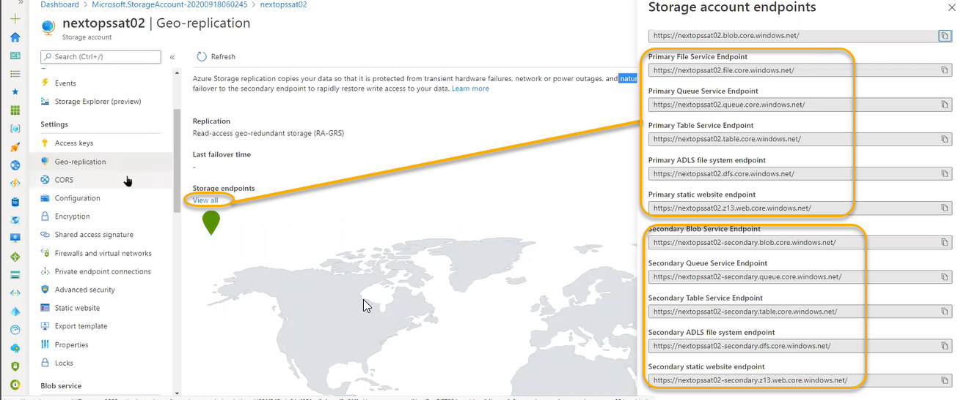

CORS

Cross origin resource sharing: It is a browser site setting if we are browsing web application website content is from one server, if you are accessing the newspaper in website and we get the ads from google how the ads are coming and how the google is identifying by means of CORS

Related to programming stuff

If they are getting the image from another website other persons from our website they need to mark as allowed origin or if we are giving our services to other websites

Other website people they want to use their images and publish on their website

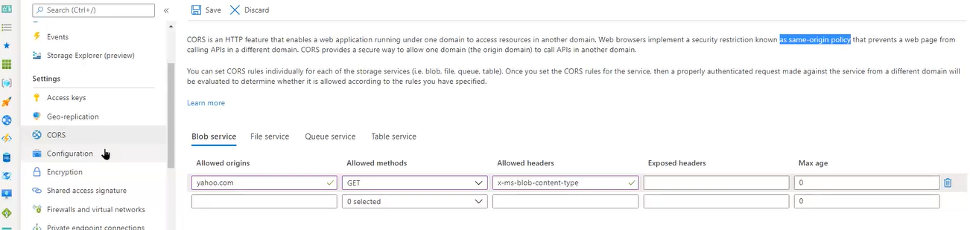

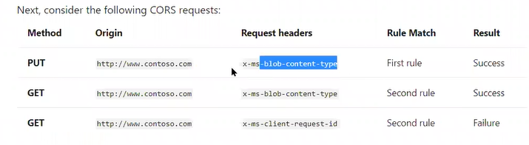

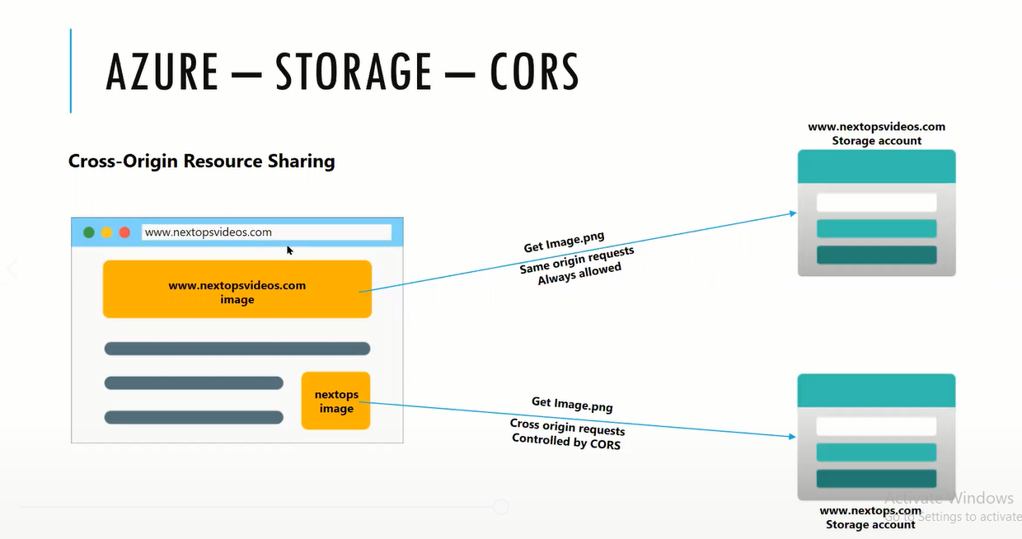

Configuration:

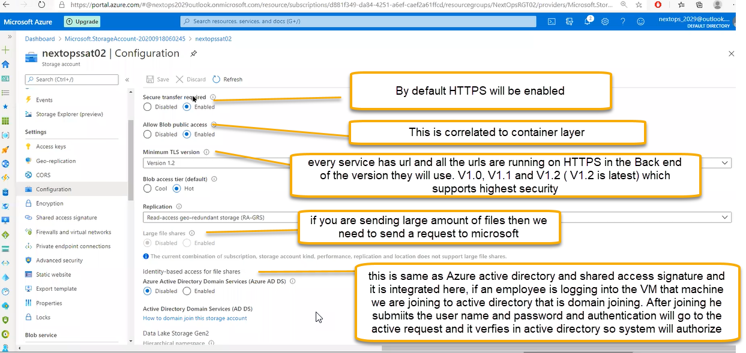

Azure Active directory domain service: to enable it we need to enable a few steps so we can join the storage account to the Azure AD. Once joined storage account access inside created user accounts Azure AD we can handle

For every company there will be centralized share point for file server. It has huge amount of storage of 10TB and they will share 100 MB , 100MB to employee quota will be allocated under network space. In that 100 MB employee will be saved important things

From azure we can do this here.

NFS: File shares in windows we called it as SMB Shares. We will create file shares locally we have drives called c and d if you read and write then we have access particularly. To arrange the particular files in a particular order we will use File system. Without file system there is no use of drives

Once we select operating system we need to format using File system

In the linux we have EXT3.

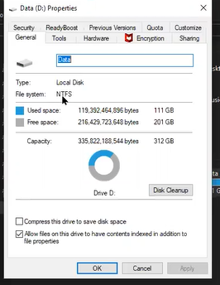

If you do Map network drive from Azure to local network then we need to follow the below process

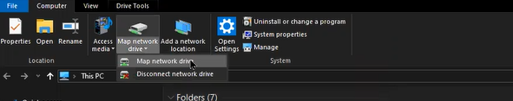

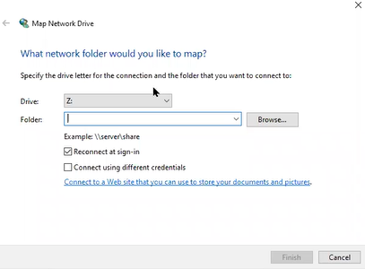

If you do connection with windows, we call it as common internet file system

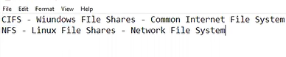

Encryption

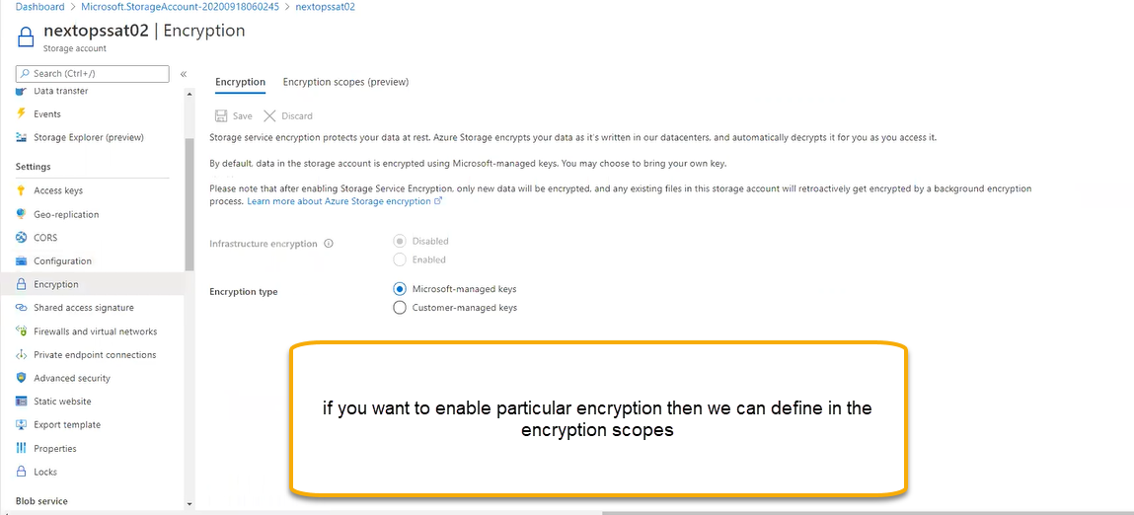

Shared access signature: SAS similar to Just in time access in the container there is a image

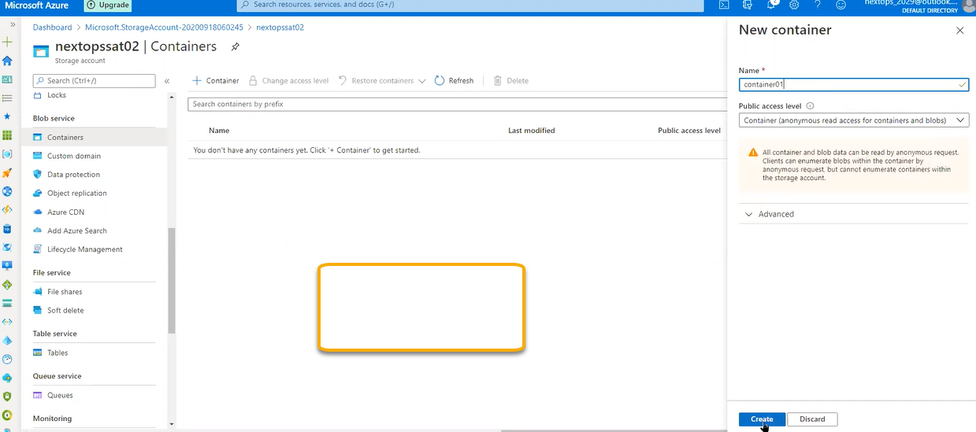

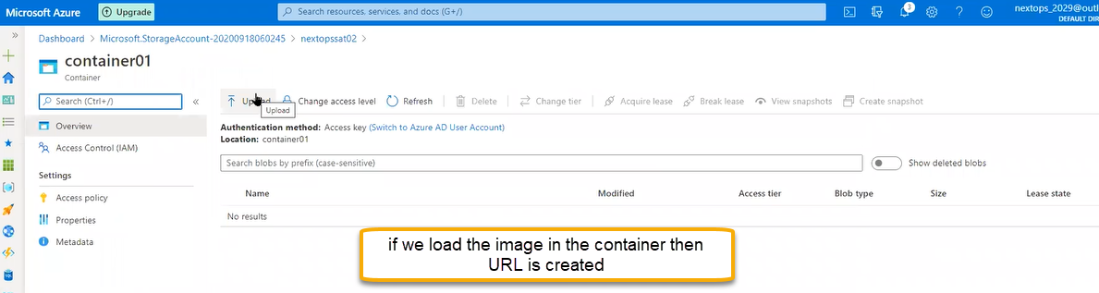

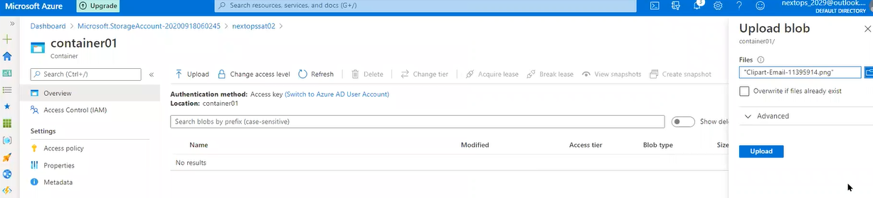

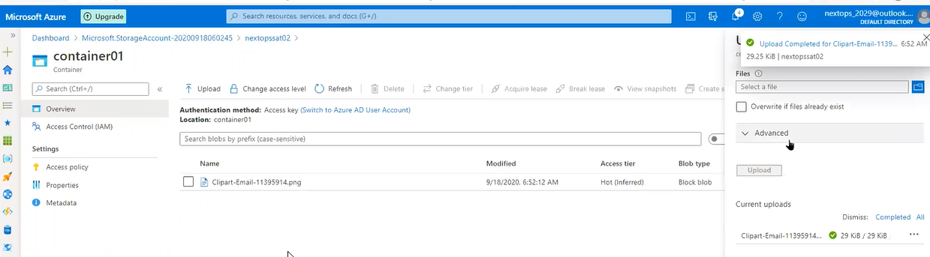

We will call it that image as blob

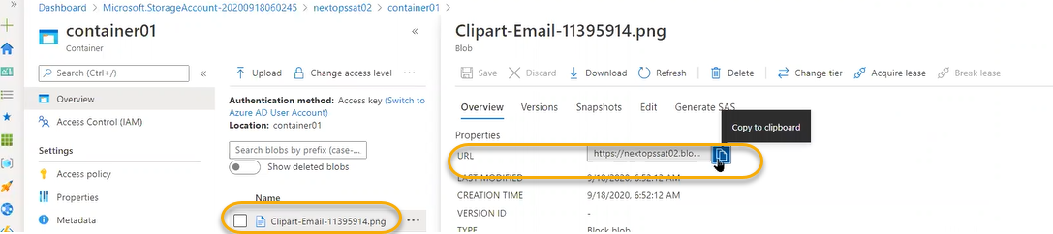

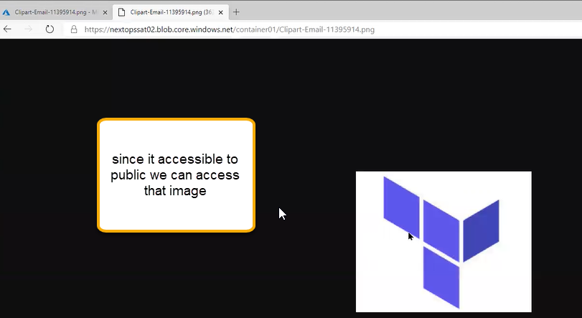

In the container level if you change to access to private then if you browse the same image in google we cannot access that url

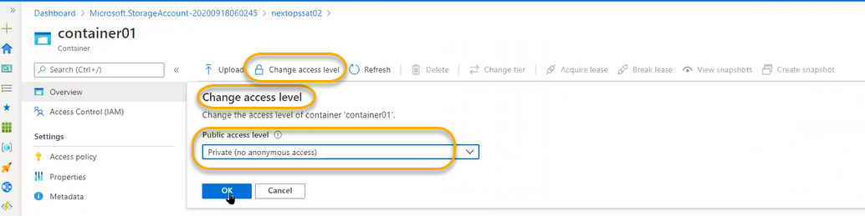

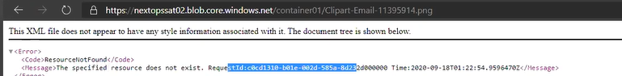

We need to access generate the SAS Keys to access the image placed in private

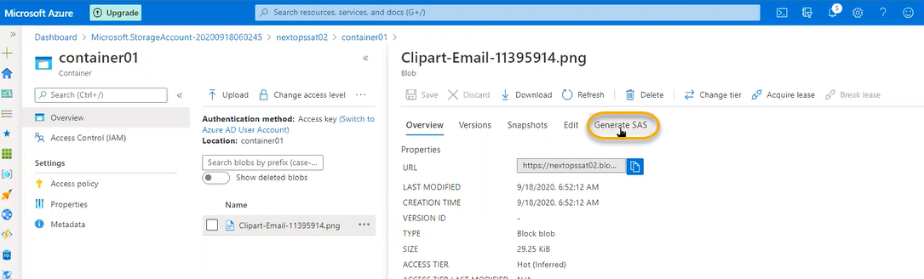

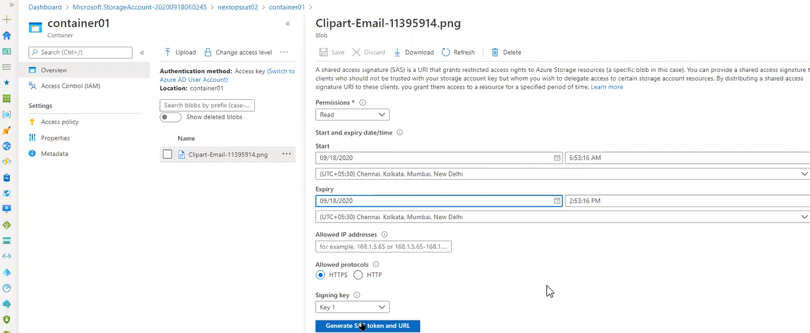

If you define the time range, then that image can be accessible up to the certain time

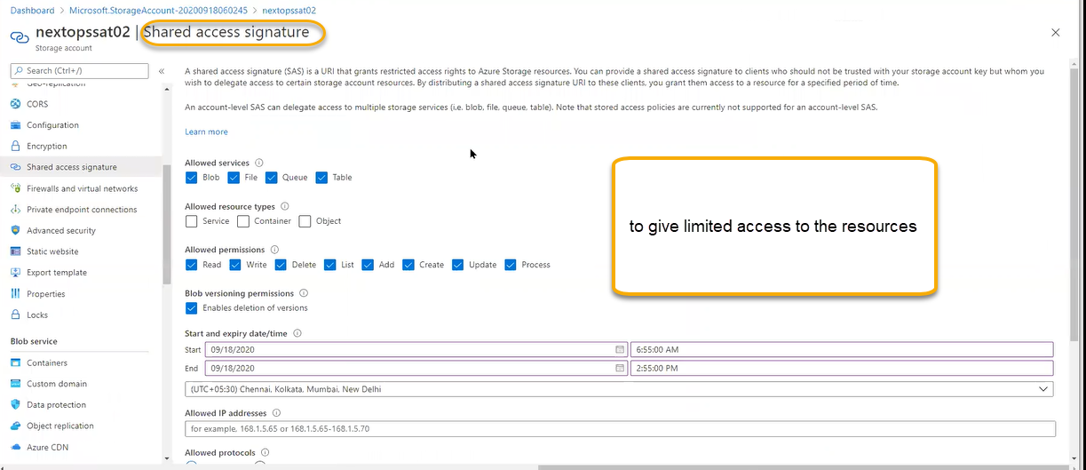

Allowed resources types:

Servicewith in the storage account service if we need to give access

Container: access to container

Object: with in the container we need to give access to file

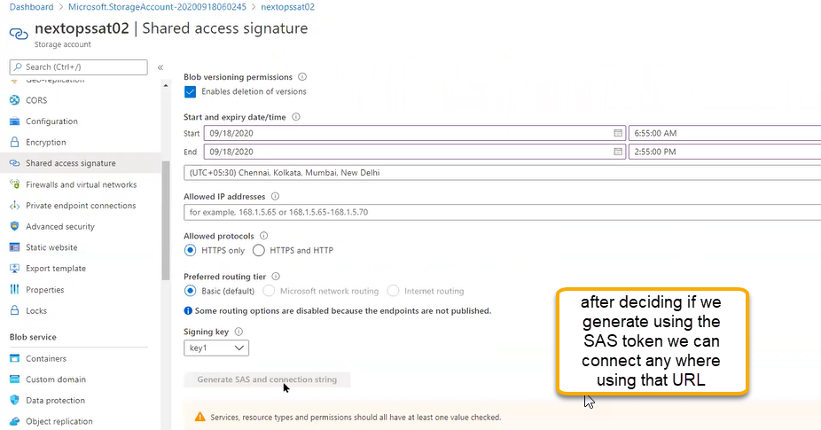

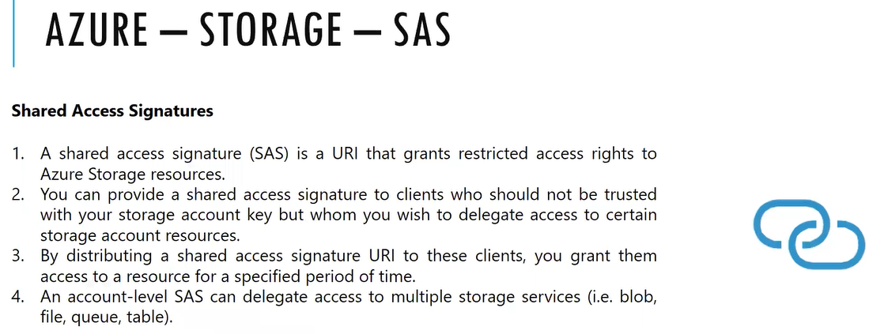

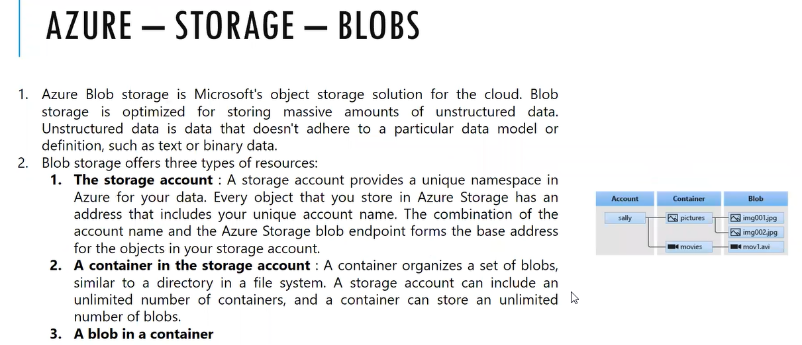

Firewall and virtual networks : similar to service end point

Private end point connection: Mapping to public end point to private end point in the vnet interface will be created vnet card. In that card a private ip will be assigned from CIDR Block

Advance security:

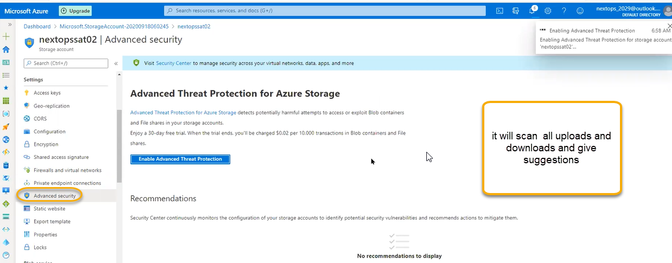

Static website: content will not change. Content will be there always constant. Google home page is static that does not need much database Dynamic means based on end user he customize look and feel Facebook is dynamic web site

To create the html > create a notepad and modify the extension as .html and if you open that file we see the content saved in the notepad.



This is static which can be changed and we can place in container

If you enable static web option then automatic folder is created in the container as $web

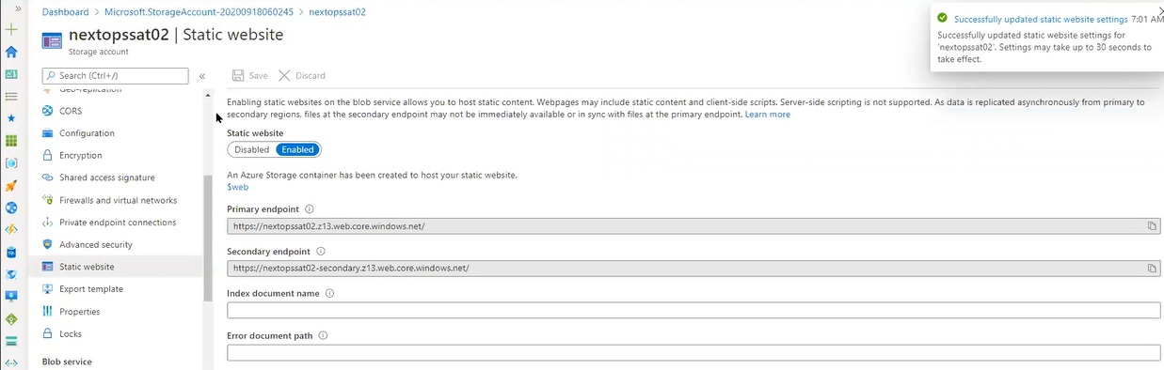

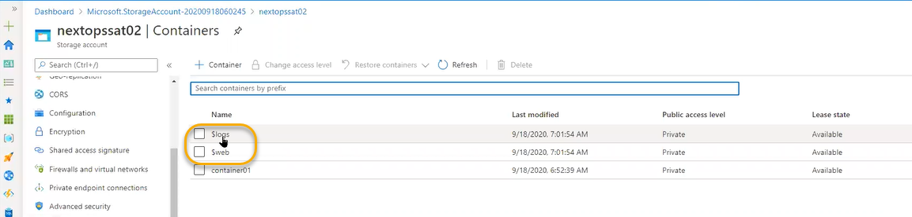

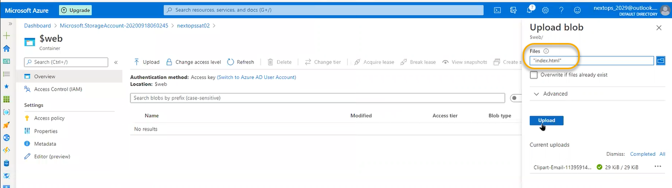

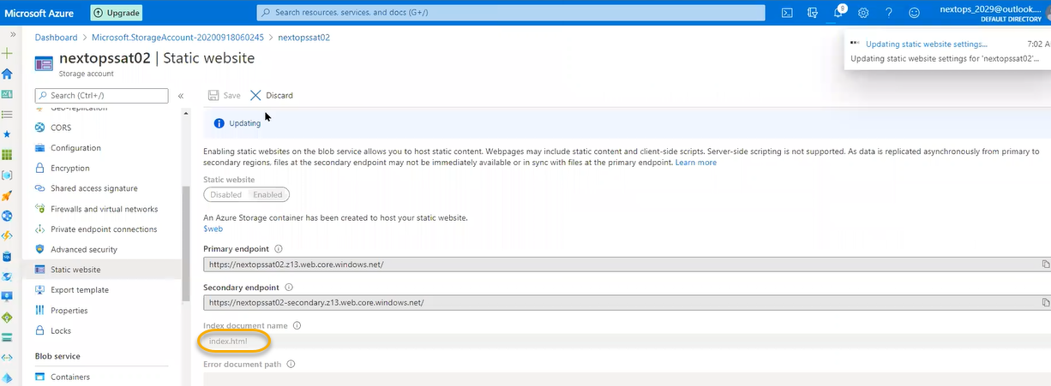

If you copy the primary end point url and paste it in google (publicly accessible website)

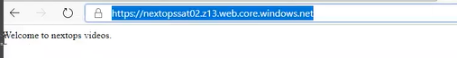

If you want to create the custom domain we can create it.

